Task 2

1. Load the country data using html and java script and run a for loop on the data and print all the country name

My code

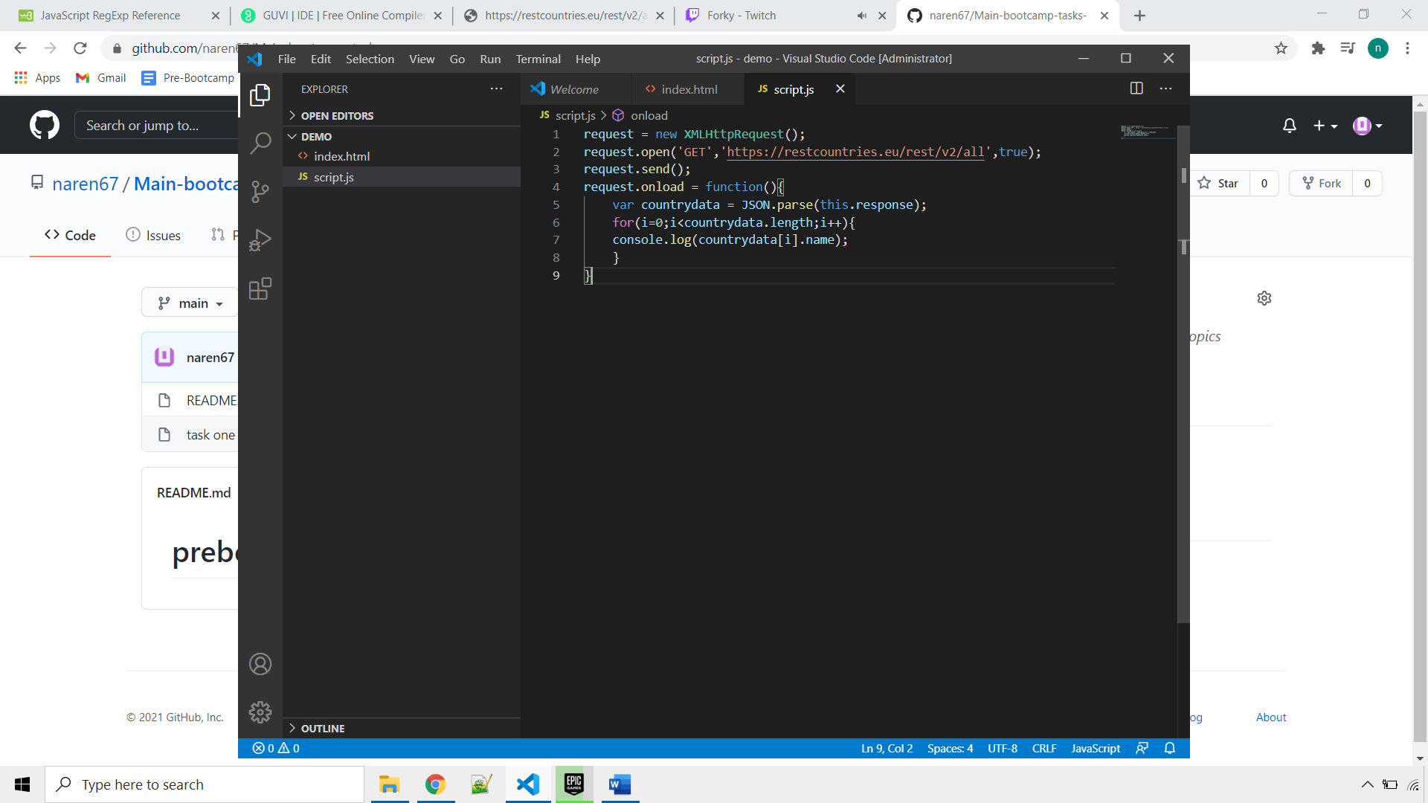

1. Difference between copy by value and copy by reference

|  |  |
| --- | --- |
| Copy by value | Copy by reference |
| It always look for the newly assigned variables and doesn’t care about if previously assigned variable has the same name | It always compare the same variable name and does some modification accordingly to the users newly added arr input |
| It creates more memory space | It deals with the same memory |
| Memory consumption might increase a lot | Less memory consumption |
| Example  Let name= “panda”;  Let name1 = name;  Let name = “ naren”;  Let name1 = “kumar”;  Console.log(name,name1);  Output  naren kumar | Example  Let arr =[10,20,30];  Let arr2 = arr;  Let arr[0]=20;  Console.log(arr,arr1);  Output  [20,20,30] [20,20,30] |

1. How to copy by value a composite datatype (arry and object)

Example using array

let arr1 = [10,20,30,40,50];

let arr2 = [...arr1];

arr2[0] = 11;

console.log(arr1,arr2);

output

[ 10, 20, 30, 40, 50 ] [ 11, 20, 30, 40, 50 ]

Example using object

let obj1 = {colour : "blue",type : "plastic"};

let obj2 = {...obj1};

obj2.colour = "white";

console.log(obj1,obj2);

output

{ colour: 'blue', type: 'plastic' } { colour: 'white', type: 'plastic' }